Dredging Sub-Committee Report

Preface:

Mulpus Brook is the primary source of surface water inflow to the lake. There are numerous other smaller inlets to the lake, which enter into various cove areas and comprise the remaining inflow to the lake

According to the survey completed by Aquatic Control Technologies (ACT) on September 16, 2008, sediment deposits have accumulated at the Mulpus inlet area, forming an expansive, shallow “delta” with abundant emergent and floating vegetation. (Area with excessive sediment estimated to be 3 acres by Aquatic). This is substantiated by DEP satellite shots of the area dating back to 1997. (attachment pending, from Jennifer Gensel, Wetlands division, central area)

According to the 2008 Vegetation Distribution map completed by Aquatic Control Technologies (page 3), the vegetation cover in the Mulpus Inlet Cove is 60-100%; vegetation is:

White Water Lily
Water shield
Ribbon-leaf Pondweed
Bladderwort
Submersed Arrowhead

Several members of the Board of Directors have stated that in their opinion the sediment level of the inlet cove has risen. Jack Kutarnia, BOD, indicated that many years ago the harvester could be operated in the cove; however at this point the shallow depth prohibits operation. Jim LeBlanc, BOD, has stated that in previous years a boat could be operated in the channel; boat operation is nearly impossible at the inlet area currently due to vegetation and shallow depth.

Causes

Causes need to be recognized so that future incidents to not reoccur. Causes that have been witnessed by abutters include:

- Water diverted by beaver dams and subsequent erosion in Mulpus Brook; the biggest factor re volume and speed of erosion
- 50 yr. storm plus boards left in the lake’s dam during spring flooding, plus kids pulling rocks away from a bank: resulting in tree and sediment around the tree’s roots washing out
- Ongoing tree washouts, due to lack of forest management along the edge of Mulpus Brook

Preventive action (continuing investigation)

- Continue to monitor beaver “chew” and trap out beavers as warranted
- Volunteers needed to help cut down trees that are ready to fall into the brook (and BOD approval needed to do so on abutting landowners property within defined, minimal setback area, and appropriate notification of landowners.
- Plantings along the banks recommended by the Natural Resources Council (NRC) back in 1996 after 50 yr. storm. NRC also recommended cutting down vulnerable trees close to the edge of the brook.
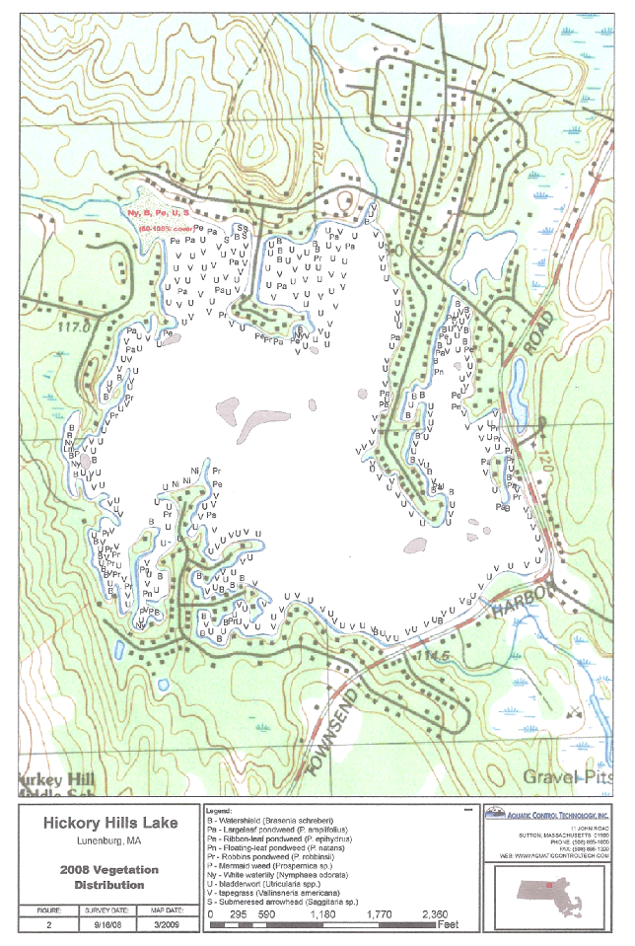
Overview of types of Dredging and Advantages/Disadvantages of Dredging
(Obtained from the Practical Guide to Lake Management in Massachusetts).

A copy of literature from Universal Water Solutions attached to this report for information on suction dredging.

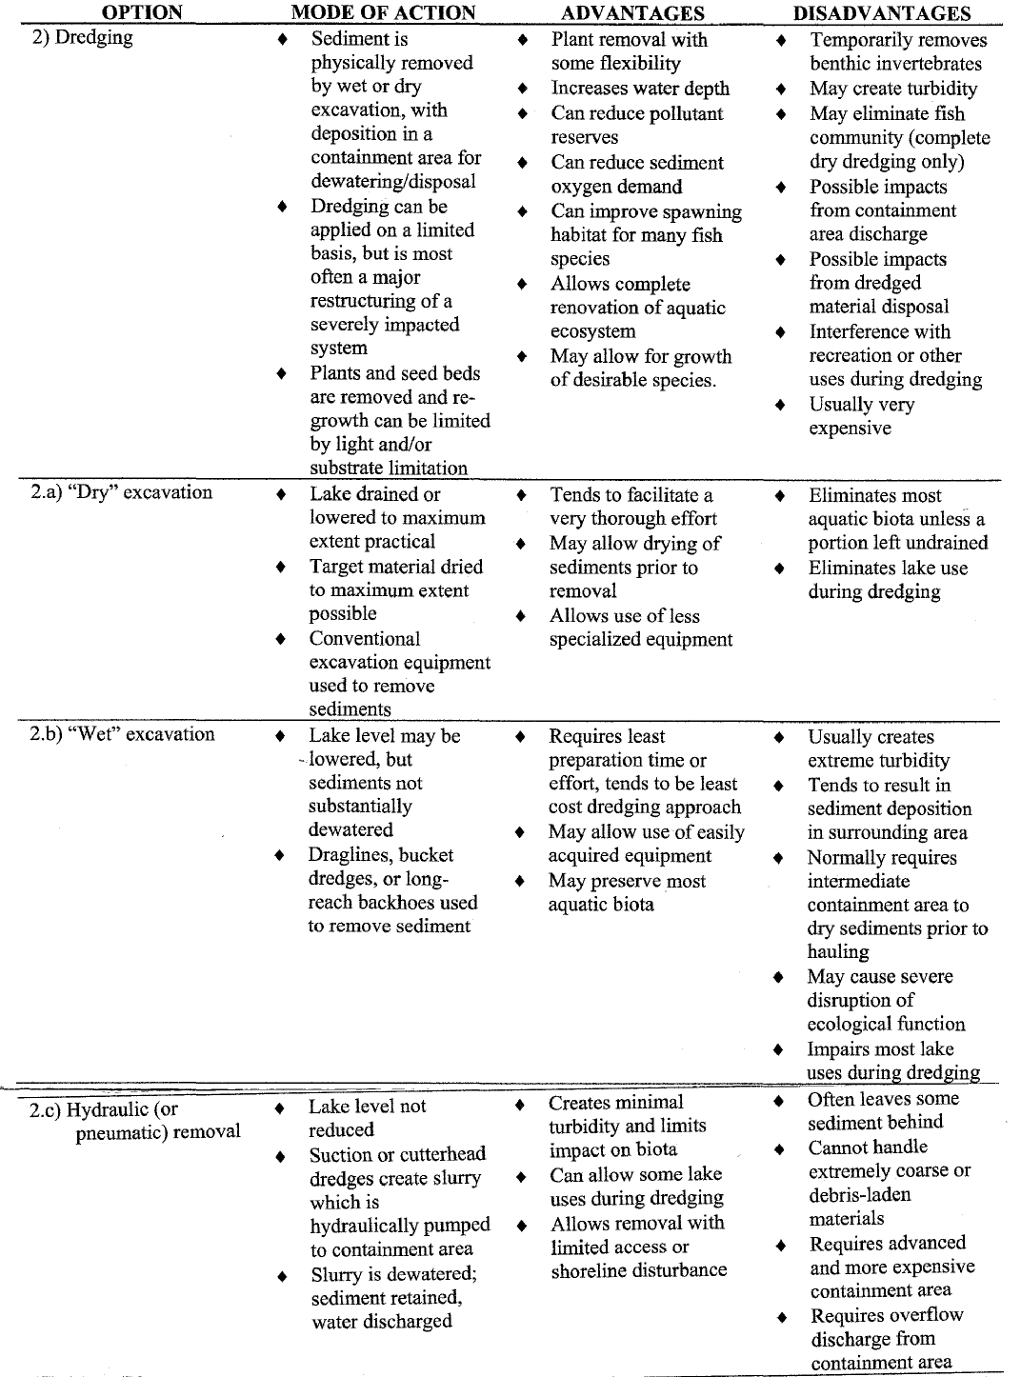

Note: Several of the disadvantages cited are probably not applicable to the proposed area if indeed the scope is limited (e.g., fragmentation of plants is not applicable as plants do not grow in the channel.) (Dominic of ACT appears to address a much larger area.)

Common Process for All Dredging Techniques

Feasibility Study

Prior to preparing a proposal a feasibility study would be required:
A component of this study would be the utilization of a GPS sonar device to probe the sediment to the hard refusal layer. Sediment Depths would be marked on a map. This map would then be utilized to calculate the amount of sediment that needs to be removed.
In order to determine the chemical compound of the sediment to be removed, one soil sample per acre would be required. The analysis of the sediment would determine the disposal options of the material.
As part of the feasibility study the hydrology needs to be investigated; knowing how quickly the lake will fill up is a crucial component of any dredging project. Maintenance of a minimum flow is also critical. The hydrology study will determine the optimum time to conduct dredging.
If the area is determined to contain endangered species; additional mapping and a filing with the EPA would be required.

Permitting
The next step would be permitting. According to Aquatic Control Technologies (ACT), dredging is extremely expensive to conduct and to permit. Permits would be required from the Conservation Commission, DEP and the Army Corps of Engineers. The price given by ACT appears to be for dry dredging. At MACOLAP, Lee Lyman of Lycott Environmental technologies quoted $50-100K for dry dredging, and $4-5K for wet dredging (no drawdown). This needs clarification and follow up with Lycott. Also, we still need permitting costs in MA for suction dredging (new for MA).

Dredging Project Commencement
Prior to commencement of the project a holding area would have to be identified for the sediment.
Access to the lake for equipment required would have to be identified.

Sediment Disposal
Once the dredging project is completed the sediment must be removed. DEP has strict regulations concerning sediment disposal. Disposal options are dependent upon the chemical composition of the material. In many instances the material can be utilized for farming and planting as fertilizer. The proposed area must be tested for heavy metal contamination, per the DEP.
Estimated Costs

Work Description | Cost Breakdown | Estimated Total Cost | Notes | Info. Source
Feasibility Study |  | $3,000 - $5,000 | 3 Acre parcel | Aquatic
Sediment Sample Analysis | $400 - $500 Per sample, 1 sample per acre required | $1,500 | 3 Acres parcel | Aquatic
Permitting |  | $100,000 | This estimate would not be unusual for a 3 acre project; permitting costs are site/town specific. | Aquatic
Dredging | 4 acre parcel with 5’ sediment = 32,000 cubic yards, $20 per cubic yard | $650,000 |  | Aquatic
 | 75’ x 100’ 3’ depth suction dredging | $15,000 | Small area in New York | Sharon Scott, Peach Tree Lake, NY
Sediment Disposal | Dependent upon composition
 | 75’ x 100’ 3’ depth $5,000 | $5,000 | Removed by Orchard Grower | Sharon Scott, Peach Tree Lake, NY

Cost can be lowered considerably by limiting the scope to “spot dredging” of a small area off the corner of the Vautour property and possibly a small area off the corner of the Andella/Reed property. This would be enough to maintain access to the lake for most of the affected properties. In addition, manual work with shovels is a consideration. Dominec says this does not require permitting. However, the DEP apparently requires permitting anytime you dig into the sediment. (per Jennifer Gensel) So, further inquiries need to be made.
Conclusion
This report is a summary of our findings, details regarding advantages/disadvantages and sources of information are available from the sub-committee members (listed alphabetically):
Paula Bertram 978 582 9658 pbertram@net1plus.com
Suzanna Dudley 978 582 4229 suzanna.dudley@hp.com
Kerry Sullivan 978 582 9748 kerrysullivan163@comcast.net

The sub-committee did intensive research into dredging; the complexity of the process was uncovered and the potential environmental impact of not doing anything to address the sedimentation became clear. If allowed to continue, the existing delta will expand, vegetation will eventually become more woody and more swamp lake. Vegetation will continue to migrate. In addition, there potentially might be a problem with using some of the other proposed lake management techniques to get into the “trap” location without dredging. (The “trap” runs out of the inlet from the corner of the Vautour property, in front of the Martinec and Andella property to the corner of the Reed property.) Due to heavy silting, the harvester cannot enter the trap area. And, it might be problematic for hydroraking equipment to enter this area without dredging enough for an entry point. (Hydro-raking is being looked at as a technique for cleaning out a wealth of leaves, twigs, and brush that have accumulated in this area.)
There may be other options to address the sedimentation in a more cost effective approach. After a complete lake management plan is close to completion, it is advisable to arrange a pre-application meeting with the DEP. The DEP can perform in an advisory capacity, but only if contacted before a Notice of Intent (NOI) is filed. After filing, their role becomes regulatory.
In order to identify the severity of the problem, a feasibility study is needed. The information obtained in the feasibility study will be valuable in determining appropriate options.

Universal Water Solutions

“Leaders in the field of Waterfront Restoration Technology”

P.O. Box 20182 Rochester N.Y. 14602

(585) 752 – 7930
www.aquacleaner.com

The Aqua Cleaner Waterfront Restoration System

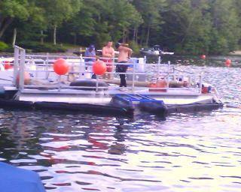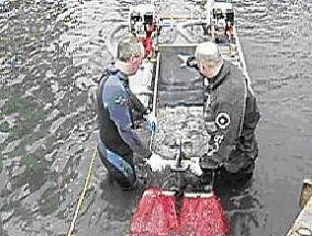
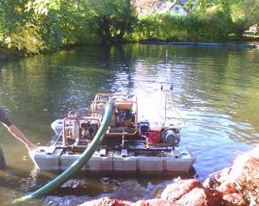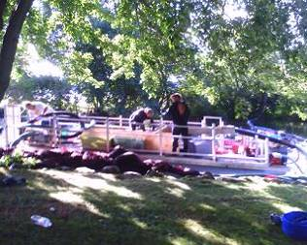

Waterfront Restoration
Universal Water Solutions is on the leading edge of technology in the field of Suction Harvesting and Spot Dredging Equipment. Suction Harvesting offers the best short and long-term solutions to controlling and eradicating the spread invasive vegetation. Dredging is no longer a nasty 8-letter word, but rather is a natural step in the restoration of any body of water. Lake Bottoms get soft and fill in through many means, which only helps further their demise.
Services Available
Lake Wide Restoration Lake Assessments Environmental Clean-Ups
Homeowner Restoration Pond Assessments Dredging (spot dredging & large scale)
Break Wall Construction Flood Pump Outs Boat House Pump Outs
Equipment Available For Sales & Lease
JOINT VENTURES AVAILABLE IN LIMITED TERRITORIES

Mission Statement
At UWS, our goal is to design, build and implement a new generation of machines that will aid in the reclamation of your water front property. We can remove problems that hinder the use of the your waterways, making them more accessible, while remaining conscious of our environment and the need to protect it. Regardless of the nature of each job, our equipment can restore your waterfront property to what it was years before all the debris filled it in. We surround ourselves with the best and brightest specialists in the waterfront restoration industry. Our staff all has personal experience and a passion for the water and the ecosystem it supports. Our equipment is based on fundamentally sound principals in keeping environmentally conscious. We perform various services and sell our equipment only after checking on all legal ramifications and procedures, always keeping in mind the delicate balance that exists between nature and man.

The Aqua Cleaner System
The core of UWS’s services comes from the strength and abilities of the Aqua Cleaner. The Aqua Cleaner’s are several unique pump designs, one a Suction Harvester and the other the smallest Gas Powered Dredge Machine. Both machines come in several different size configurations depending on the required applications.

The Aqua Cleaner Vegger is a Suction Harvester that is designed to suck up any type of solids that will pass through a hose. These include aquatic vegetation, leaves, rocks, zebra mussels, sticks and other debris.
S.H. has been around since the 80’s but nobody has refined it and made it easier to use, bigger and more efficient. Trying to capture debris while moving at least 800 gpm is a difficult task and knowing how to operate a nozzle is even more trying. U.W.S. makes it as easy as using your lawn mower.

The Aqua Cleaner Dredger is designed strictly as a portable dredge machine that will suck up silt, sand and other soft organic material. It uses water agitation to create a slurry and can pump over 1000’ away without a booster.

Aqua Cleaner Vegger
A powerful suction harvester that operates with a man under the water extracting unwanted plants by the rooting system so that they don’t grow back as fast. The machine is equipped with a duel bagging system that allows the water to pass through them, while capturing the plants, rocks, sticks, leaves and assorted debris. This machine is an environmentally friendly means of dealing with an overwhelming problem.
Vegetation Capacity – 50 to 500 Square feet per hour depending on the type of plant, density, and rooting system.
5’ x 10’ pontoon with 2 pumps, diver air compressor and comes with a 4”, 5” and 6” hose configuration.

Aqua Cleaner Octopus- A large pontoon boat (24’ – 28’) suction harvester designed for large vegetation and debris removal with multiple nozzles feeding it onto our large pontoon boat, where it can be de watered, and then shipped to a dump barge.

Aqua Cleaner Dredger
Bigger is not better when it comes to home or spot dredging. One person, who stands in the water with a custom-built control rod, operates our dredge machine. The water agitator creates a slurry, which then goes through the suction hose. It is the most environmentally sound method of dredging that is capable of removing between 10 – 20 cubic yards per hour (1 – 2 dump trucks) and can pump up to 1000’ away.

Aqua Winch – A portable, self contained winch with motor that can be placed at the waters edge and will pull up to 10,000 lbs items out of the water. When used with our Aqua Claw Rake it can remove large amounts of Cat Tails or other tuber rooted plants.

Aqua Cutter – A self-contained pressure water that will cut any organic rooting system, and is mounted on a small pontoon or operated on shoreline, and has a built in feeder pump.

Applications and Services: Waterfront Property
The Aqua Cleaner System is a new approach to an age-old problem of aquatic weed removal and long-term restoration of water front property. The DEC offices in several states are already familiar with our equipment and have allowed work in even the most sensitive areas. Some states don’t require any permit in waters that are not designated wetlands. Our staff stands ready to assist in permits in any state, and for any project.
Suction Harvesting - Comparisons:
- Chemicals – A short term solution to aquatic vegetation problems because they only kill a portion of the plants, which then drops to the bottom and turns into silt. It also allows for substantial re-growth, is harmful to your waterways, and while killing the plants, they still leave their remains floating in your waterway.
- Weed Harvesters – Cutting vegetation is the old, obsolete method for removing weeds. It has many drawbacks. They leave clippings to collect all over your property and create a mess. Harvesters also spread and create new fragments because they fail to capture all the clippings. In addition harvesters are large, bulky machines that can’t cut close to your docks and known to have large amounts of fish kills.
- Grass eating Carp – While being a potentially a good long-term solution for an entire waterway, carp are of little value to your own property. When you purchase these fish, they are so small that they can’t eat much vegetation till they are older. They are also picky eaters and will only eat from a select menu. In some documented cases these fish have removed all the vegetation in a given waterway causing more problems.
- Excavators – This is the only other way to remove unwanted aquatic vegetation and perform dredging. However, it is very messy and ineffective because an excavator can only reach out 15’ from shore and when used for dredging removes small amounts of silt and a high percentage of water, making it impossible to capture much of the desired material.
Aqua Cleaner Vegger
Science behind the Aqua Cleaner: Your waterfront property is basically an aquatic garden. It is the optimal environment for aquatic vegetation to grow in because it has all the ingredients that vegetation needs to flourish; water, sun, and a rich soil. If you look at your back yard and use that as an example you can further understand the dynamics of what takes place in the water. You have the perfect yard but your neighbor has a bunch of dandelions. The wind blows the wrong way and now you have dandelions (the water is a much better medium than air). If you try to remove the dandelions by pulling them or cutting them they will still grow back. However if you dig them out and excavate the roots, the odds are much greater that the re-growth will be minimized. Because water is constantly moving, it carries fragments from these invasive plants. When these fragments land on your property they can take root and grow. Using chemicals only makes the problem worse because when a plant dies, it drops to the bottom, decomposes and breaks into fragments, which causes additional re-growth next season. Again, harvesters also make the problem worse because when you cut a plant you are spreading fragments, that will fall to the bottom and take hold as well. (Ask any landscaper, and they’ll tell you… if you want thicker grass, just keep cutting it).
How It Works: Suction Harvesting is the most effective way of removing aquatic vegetation because it removes the blooming vegetation by the roots, as well as the years past plants laying on the bottom in their semi decomposing state. This process can reduce the re-growth to as little as 10% next season but we have experienced as much as 50% depending on variables. It leaves no remains (floaters), can operate in the tightest areas (around docks and break walls) and is environmentally friendly. We can suction up a fish and it comes through the hose without going through a motor, and then is returned into the water.
The Aqua Cleaner machine is essentially an underwater vacuum cleaner. The machine is mounted on 5’ X 10’ pontoons and floats on the water. The system also has a compressor that continuously provides air by way of a hose and respirator. The diver uproots the targeted plants, the years past decomposing plants and feeds them into a vacuum hose that conveys them to the surface. There, a second worker bags them in 50-pound onion bags. The weeds and all the solids go into the bag, while the water passes through the mesh bag and back into the lake. When a bag is full it is placed onto a raft that is later taken to shore where the bags can be composted or trucked offsite.

STOP THE CYCLE
Aquatic vegetation grows and dies each year, sending the carcass of the plant to the lakes bottom. There they decompose and fragment, which only increases the density of the plants in following season’s and adds to the build up of organic sediment. Suction Harvesting slows this process down and over repeated use, will stop this vicious cycle. In contrast with chemical treatments or weed cutters, we also offer the advantage of selectivity. If you want only the milfoil removed but want the lily pads to remain untouched, we can easily accommodate your desires. In the end it may be necessary to dredge out a given area to remove the organic sediment and reduce the nutrient load.
Dredging:
The traditional method for removing soil entailed having a large construction excavator operate either from your dock or out on a barge. This process is imprecise and not very effective. Scooping large volumes of soil from a water way is intrusive, disrupting the ecosystem and doesn’t afford a close tight cleaning. In ponds the risks are far greater. Pumps are the preferred method of dredging but the norm in the industry are large, aggressive machines, which move huge amounts of water and silt which are very hard to manage in a small contained area like your backyard of your lakefront property.

The Aqua Cleaner operates by sucking up silt and water together and pumping it to a desired location. The most cost effective method involves pumping the material into a field and letting the water and sediment dissipate and be absorbed into the ground. Our second option is to pump the silt and water (slurry) into a dewatering bag that sits on your property. The water slowly leaches out and over a short period of time, the silt contained in the bag will harden and can then be removed. Silt is typically composed of a very pure, organic material (great for composting), which can be spread over your lawn or given to local landscapers or farmers.
Site Plan For Dredging: A) Mark off area to be dredged. B) Build staging area C) Pump out soil into the staging area and allow to de water and dry D) Move soil onto dump trucks E) Cart away soil

The benefits of the Aqua Cleaner Dredging System are many. Aqua cleaner can return your property to the original hard packed bottom. We can get into all tight spaces around docks and barges and carve out a more precise removal of soil. We can assist you in obtaining all permits and disposal requirements.
Options
Purchase of Equipment- We can sell you any of our products with complete training, servicing and permitting.
Lease of Equipment- You can lease our equipment for individual projects or demonstrations.
Service Work- If you can get us enough clients, we’ll travel to your lake to show off our wears.
Business Opportunity- If you’re looking for a great niche business, this is it!!!
. 