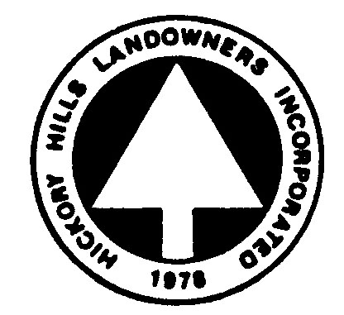
HHL Email Blast Request Form
For HHL Committee use only

HHL Committee Chairs:

To request an email blast to Hickory Hills residents regarding a Hickory Hills project or event, complete the form below and send to the office at hickoryhills@net1plus.com

Before submitting this form, I confirmed all interested parties
have approved the content & formatting below

1. Who do I want the email to go to (identify one or more from the list below):

a) All Residents
b) Lakefront residents only
c) Residents with one or more Motor Boat only
d) Residents with ANY Boat only (paddle, kayak, pontoon, etc…)

2. Enter the email’s subject line below:

3. Enter the file name of the optional email attachment below:
Don’t forget to send the attachment with this form.

4. Enter the Body of the email below:
Be sure to include any formatting of text and images just as you’d like it sent, i.e., text & image placement, font, color, etc…

